Test Case Ingestion via Backend:
Created a database as db_repository
Collection as collection_testcases
Vector search index as Vector_index_testcases
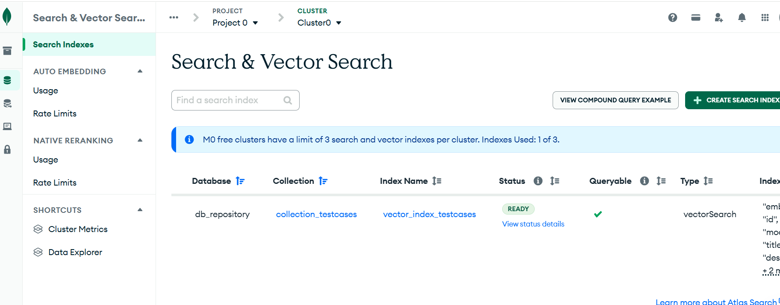

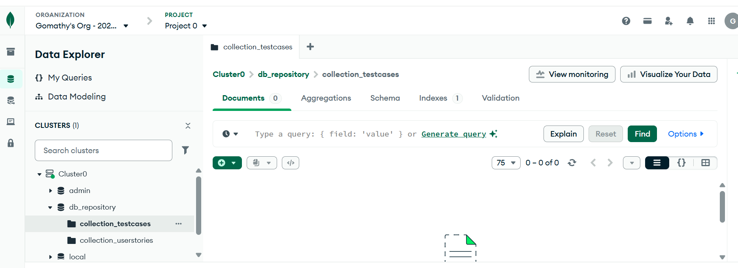

Now update the .env file
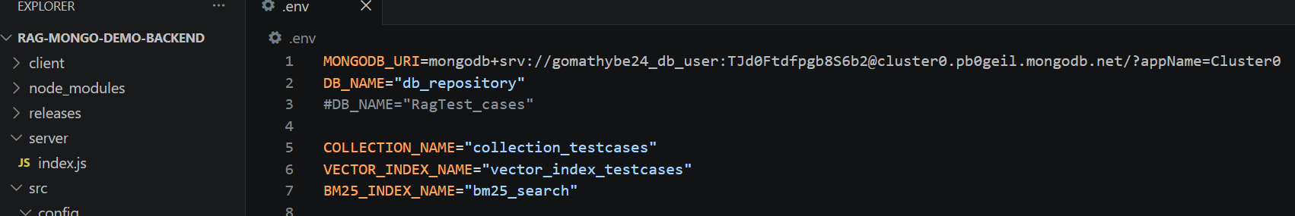

- Convert Excel to JSON
node src/scripts/data-conversion/excel-to-json.js
Transforms your Excel test case file into a structured JSON format ready for embedding.

- Create Embeddings & Store Data
node src/scripts/embeddings/create-embeddings-batch-mistral.js

Generates vector embeddings using Mistral AI and stores the documents in your MongoDB collection
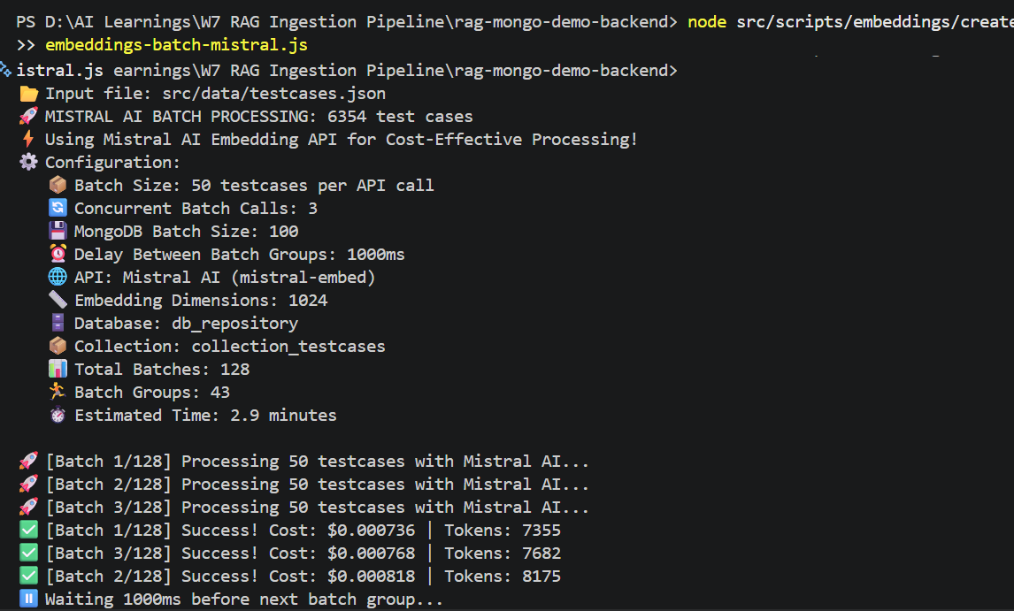
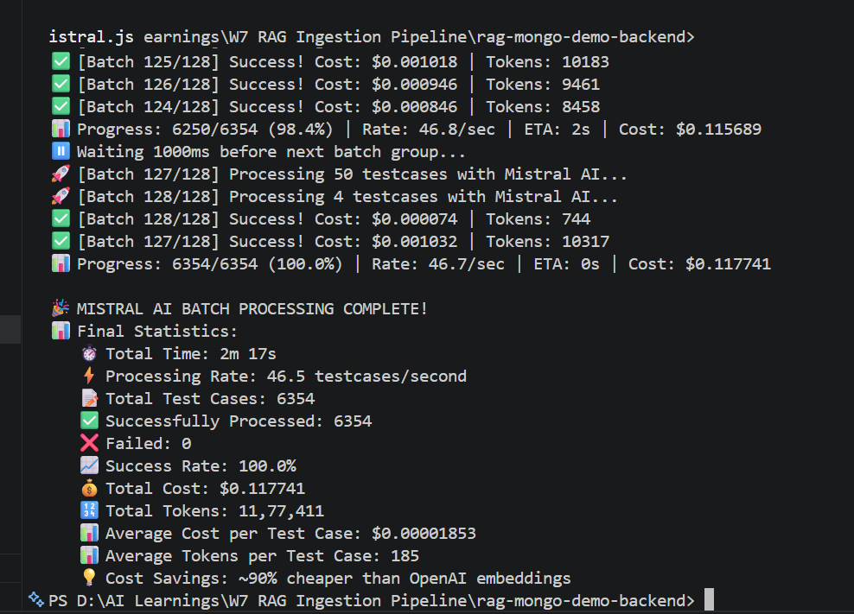

- Verify in MongoDB
Once the command completes, open MongoDB Atlas and navigate to your collection. Confirm the documents are visible and correctly structured.

6354 test cases stored in DB
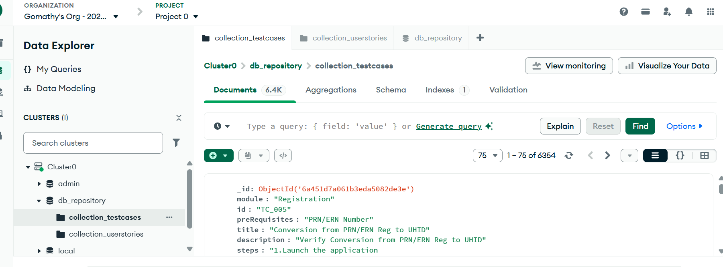

Test Cases Ingestion via API
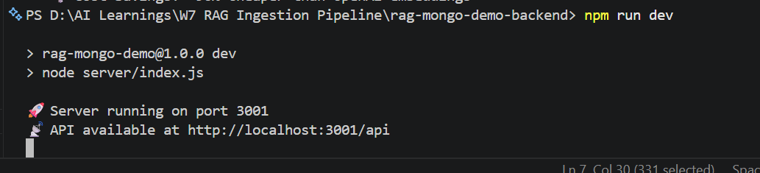

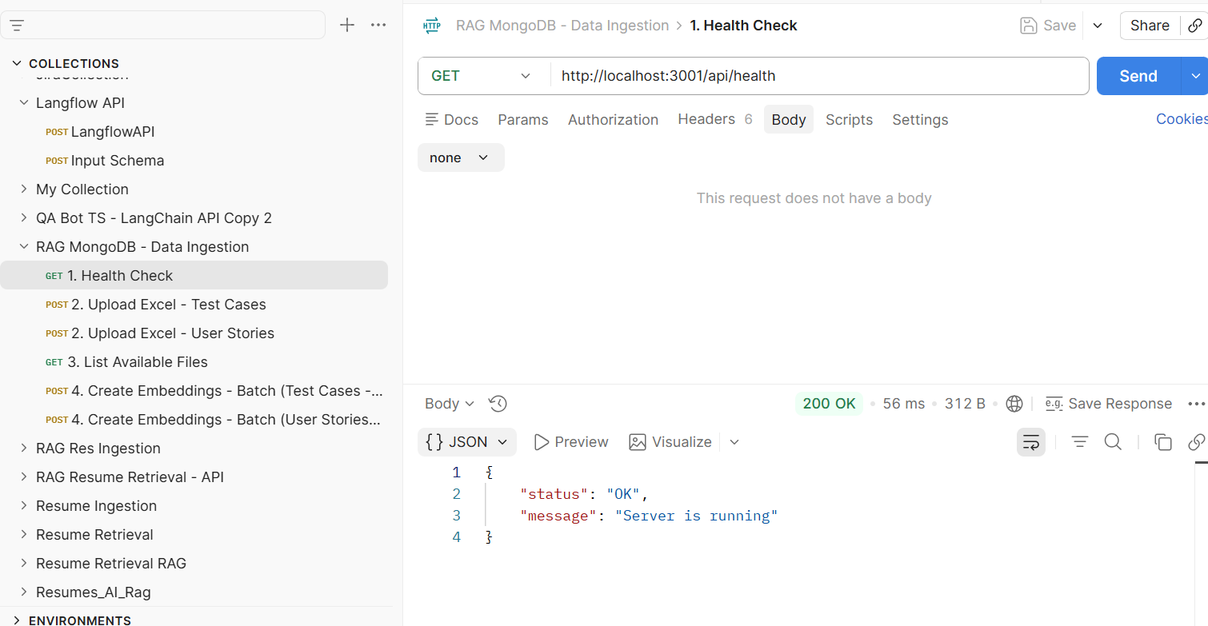

Test Cases excel file is converted to JSON
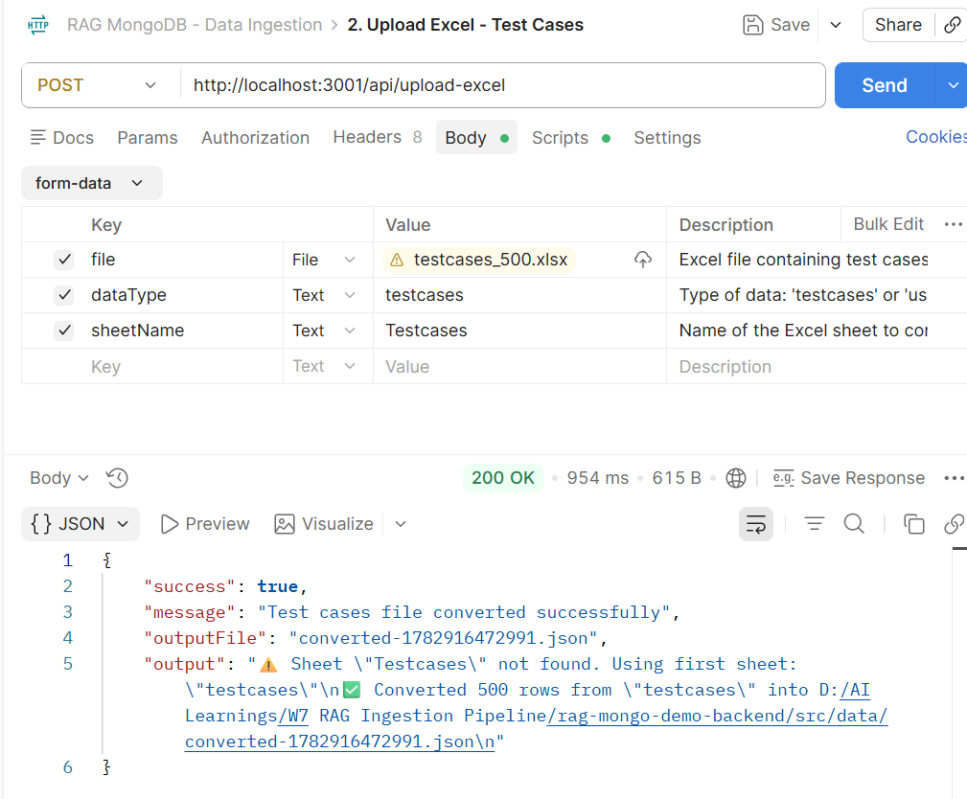

Embeddings:

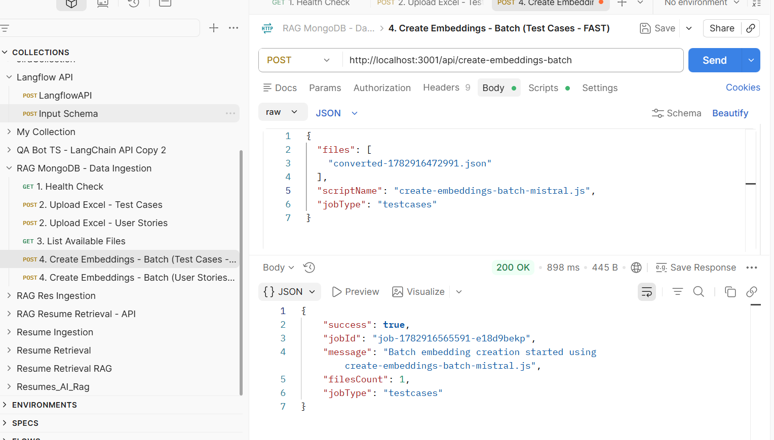

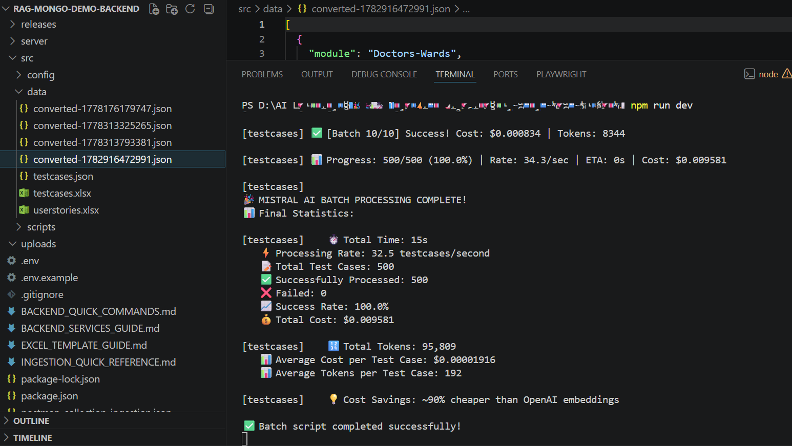

Now Validate in Mongo DB, the count is updated to 6853 (500 test cases added via API)

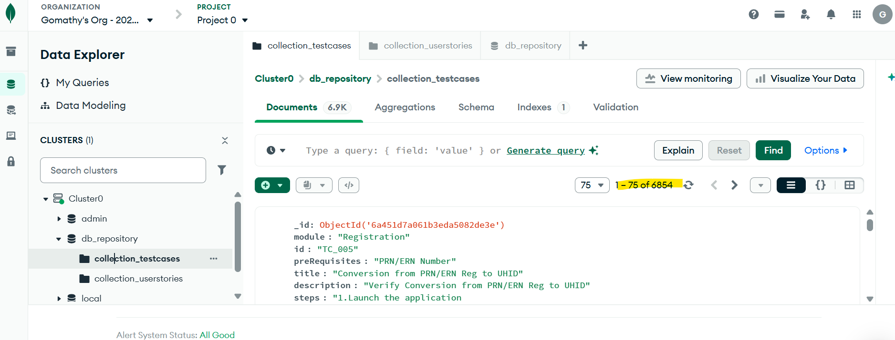

Ingestion – User Stories via UI
Created a database as db_repository
Collection as collection_userstories
Vector search index as Vector_index_ userstories

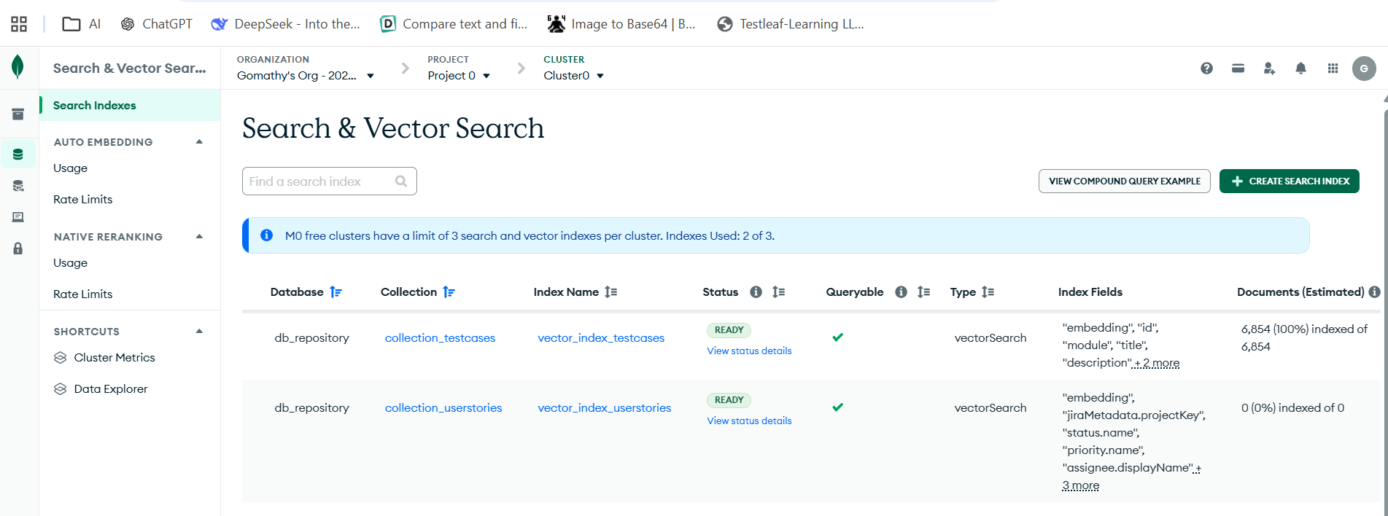

Update the .env and run the command npm run dev to bring the server up

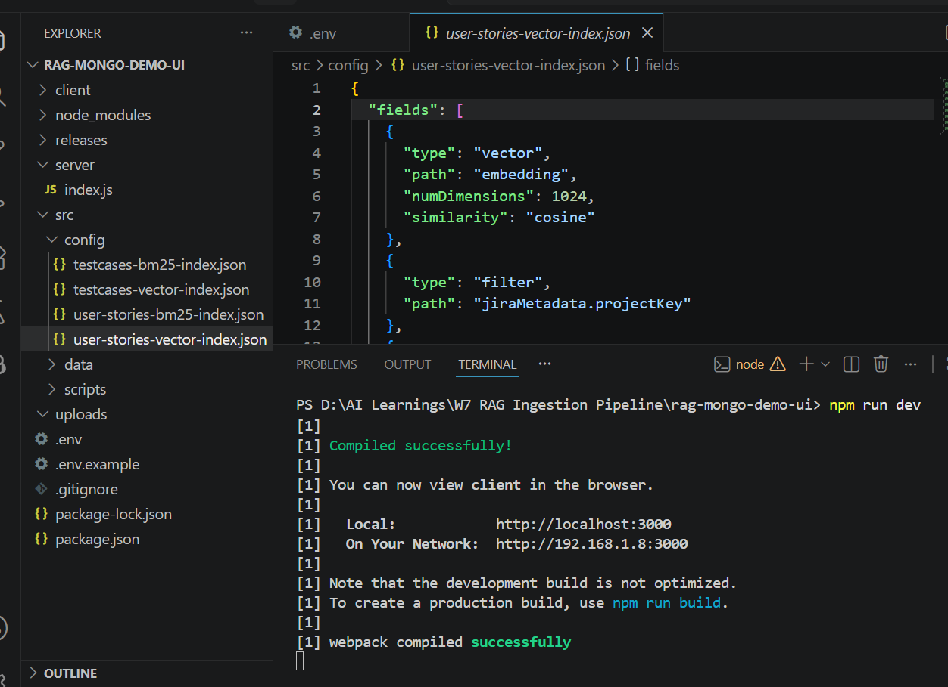

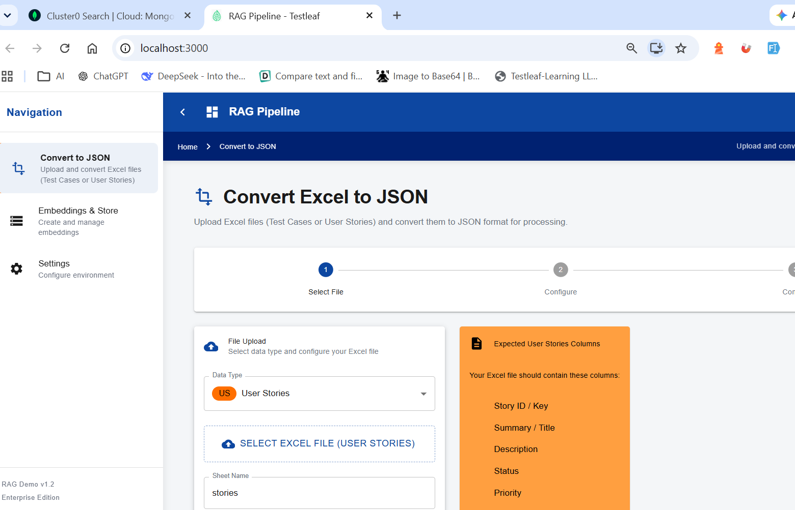

Select the Userstory file to be converted and stored

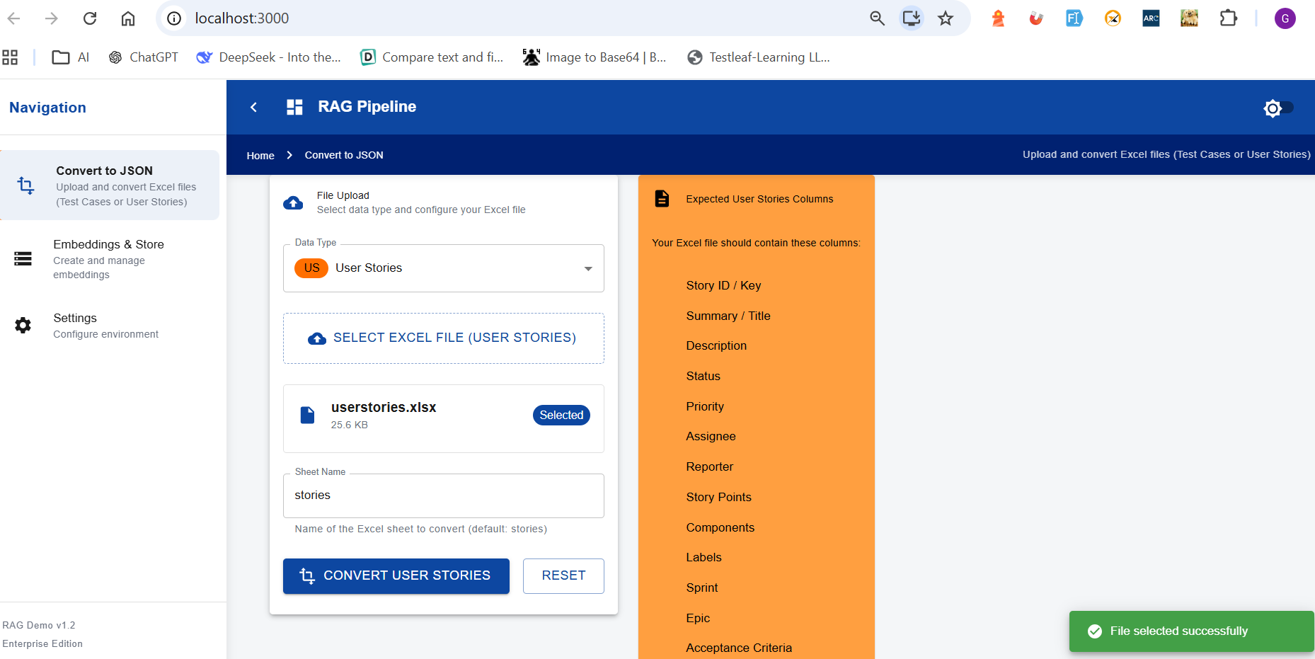

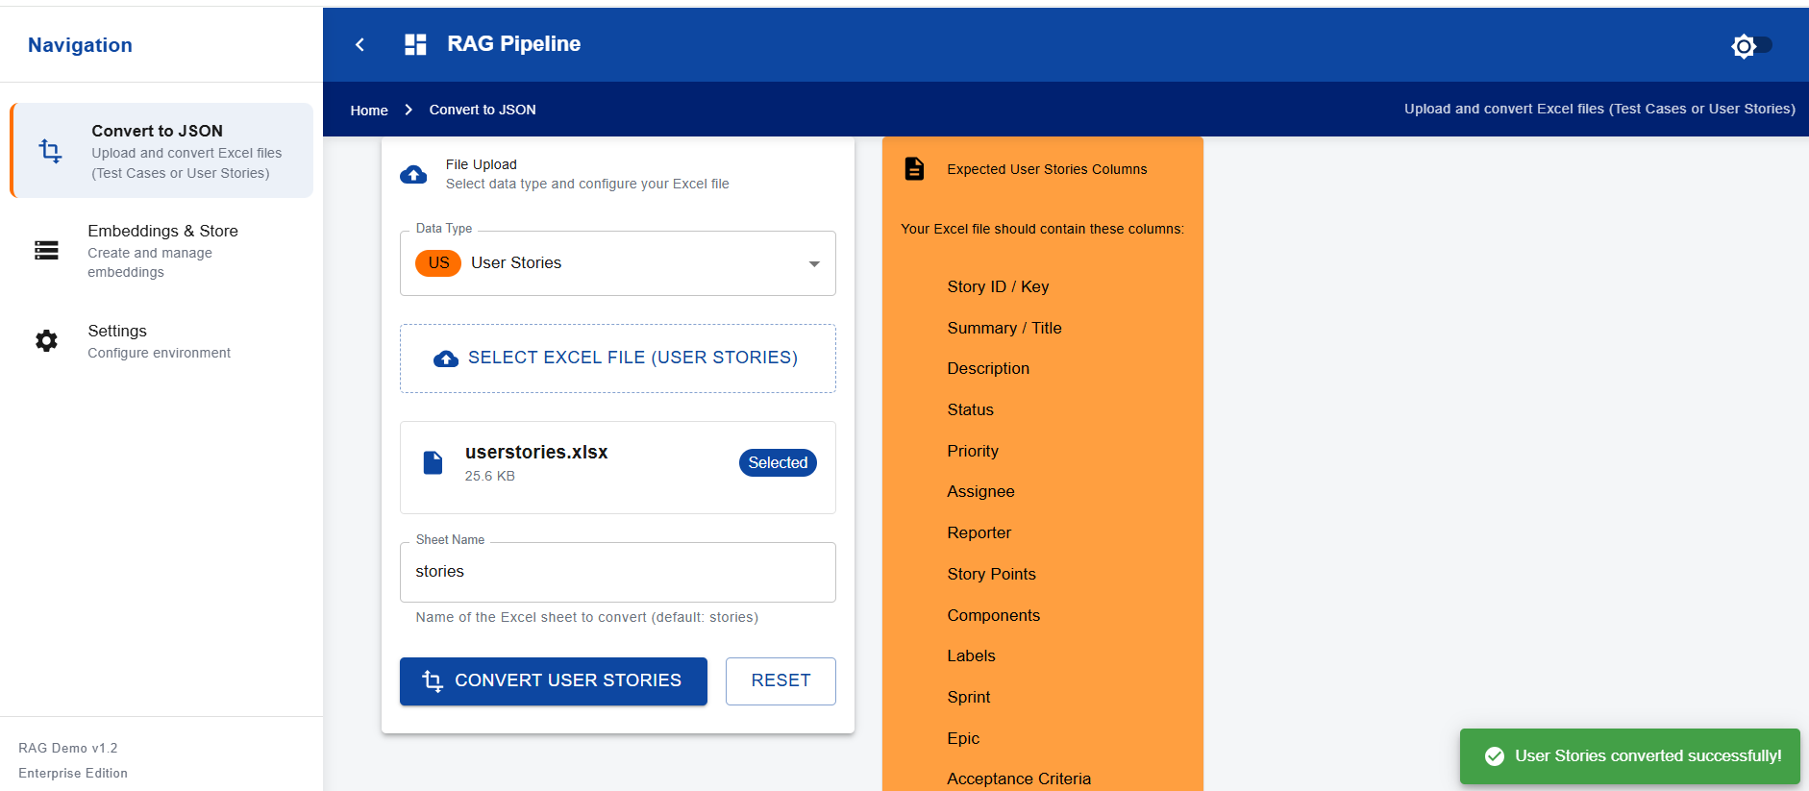

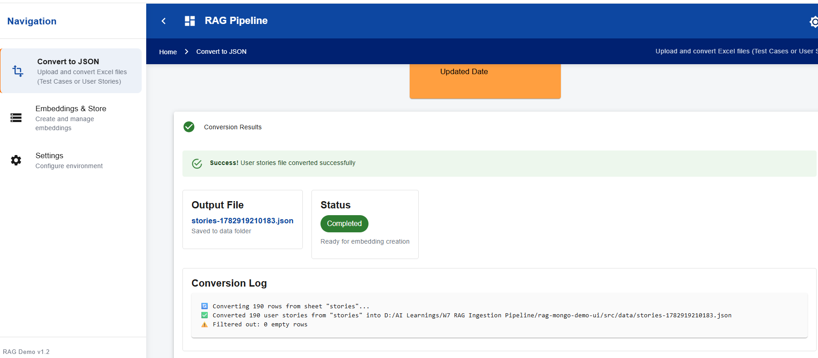

Create Embeddings:

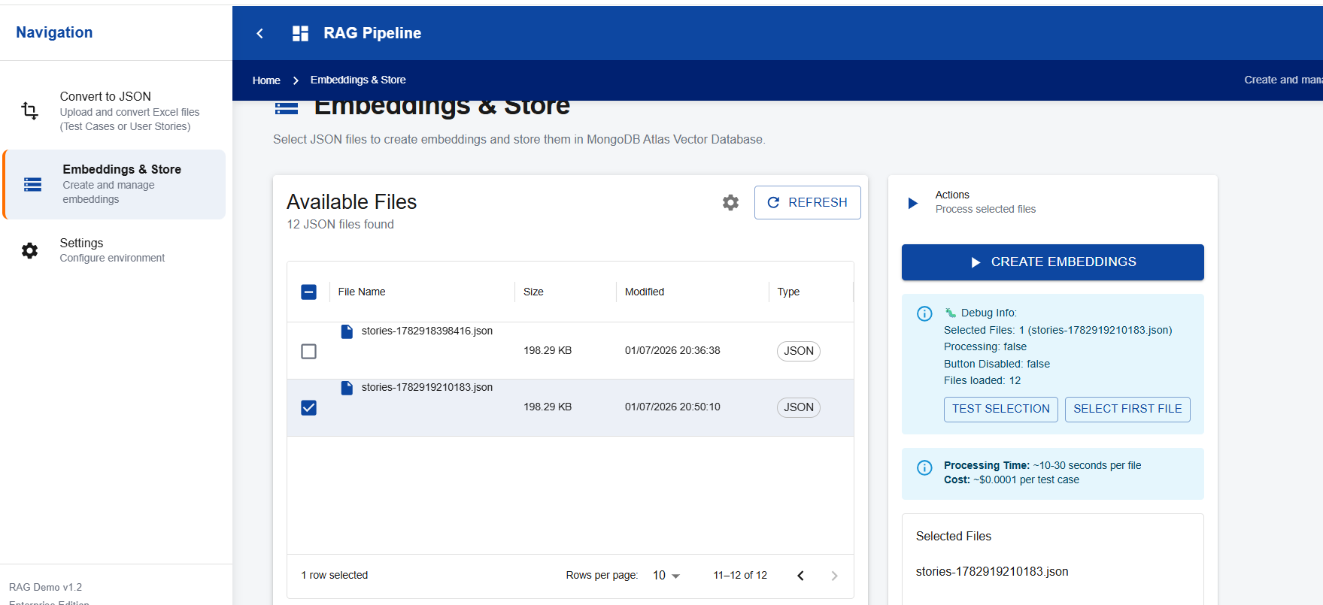

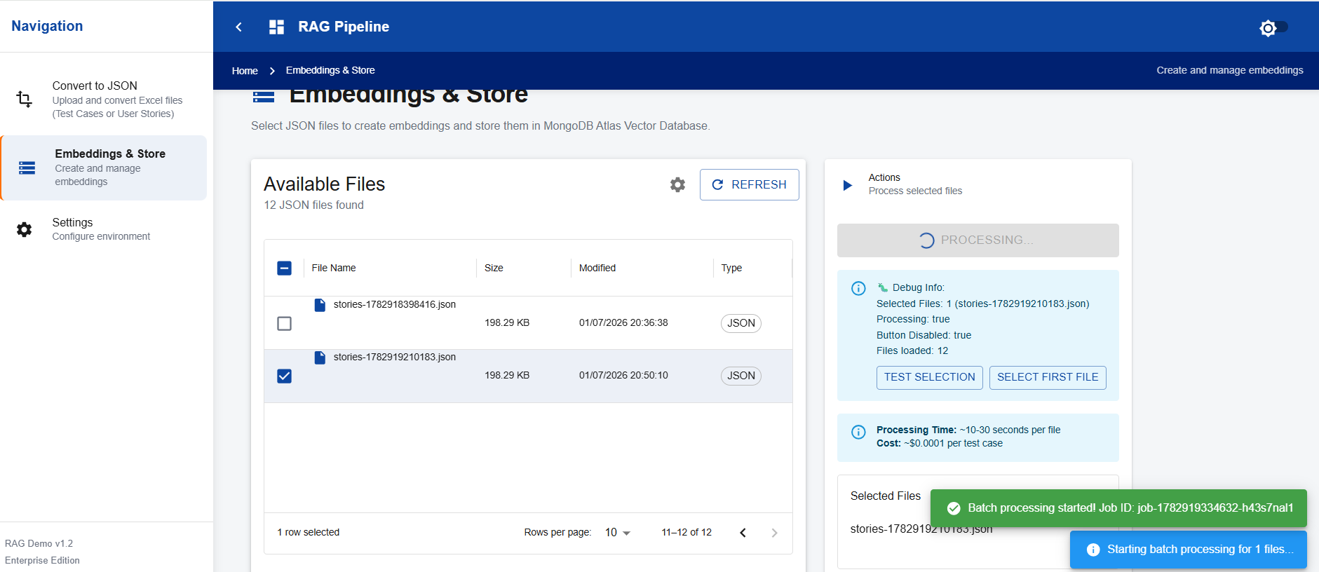

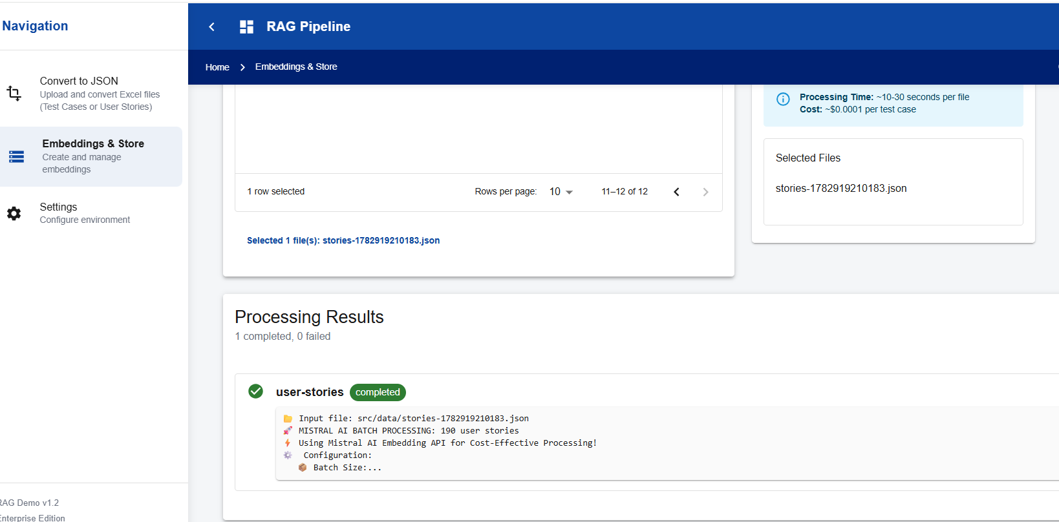

Backend
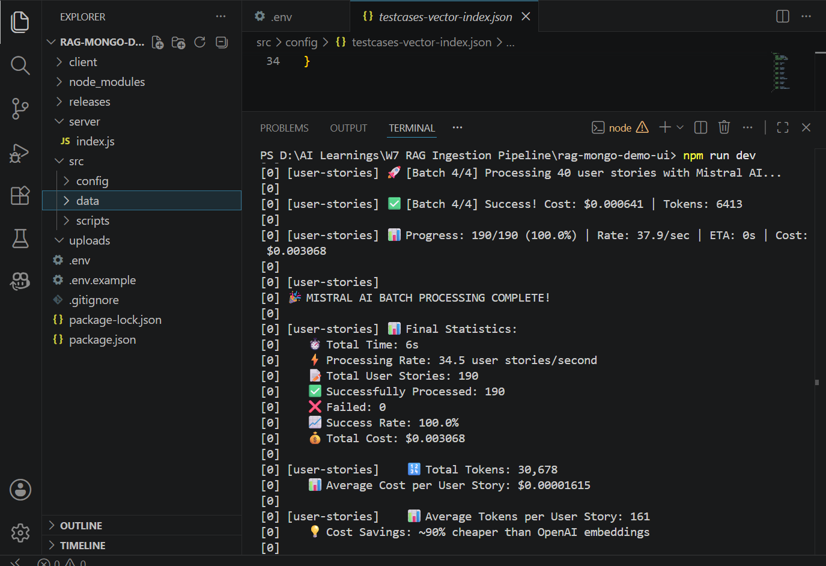

Stored in mongo db

